**NYU Polytechnic School of Engineering**

**Computer Science and Engineering**

**Project Title: Smart Café**

Software Engineering Standards

**System Requirements Specification**

Version 1.2

Document Number: SRS-001

**Team A1**

Project Members:

**Samuel Huang (sh3244)**

**Ryan Goudjil (rg2398)**

**John J. Simon (jjs597)**

**Chia-Ching Song (ccs401)**

**REVIEW AND APPROVALS**

|  |  |  |  |
| --- | --- | --- | --- |
| **Name** | **Function** | **Date** | **Signature** |
| **Ryan Goudjil** | **Author, Reviser** | **10/13/15** | **R.G.** |
| **Samuel Huang** | **Author, Reviser** | **10/13/15** | **S.H.** |
| **Chia-Ching Song** | **Author, Reviser** | **10/13/15** | **C.S.** |
| **John Simon** | **Author, Reviser** | **10/13/15** | **J.S.** |

**REVISION LEVEL**

|  |  |  |
| --- | --- | --- |
| **Date** | **Revision Number** | **Purpose** |
| **10/13/15** | **Version 1.0** | **Initial Release** |
| **10/18/15** | **Version 1.1** | **Fix Document Defects** |
| **10/21/15** | **Version 2.0** | **Added Functional Requirements** |
| **10/30/15** | **Version 2.1** | **Fix Document Defects** |

Table of Contents

1. Introduction 4

1.1 Purpose 4

2. Scope 4

2.1 Identification 4

2.2 Bounds 4

2.3 Objectives 4

3. Overall System Overview 6

3.1 Context Diagram 6

3.2 Additional Descriptive Items 6

4. Document Overview 7

5. Reference Documents 7

6. Business Requirements 7

6.1 Technology 7

6.2 Business 7

6.3 Regulatory and Legal 7

6.4 Market Considerations 8

6.5 Risks and Alternatives 8

6.6 Human Resources and Training 8

7. Specific Requirements 8

7.1 Functional Descriptive Detailed Requirements 8

7.2 Requirement Uses Case 10

7.3 Non-Functional Descriptive Detailed Requirements 12

8. System Test Plan Requirements 12

9. Qualification Provisions 12

10. Requirements Traceability 13

11. Evolution of the SRS 13

12. Rationale 13

13. Notes 14

14. Appendices 14

14.1 Schedule Tracking 14

14.2 Defect tracking 14

# 1. Introduction

## 1.1 Purpose

The purpose of this SRS is to delineate our requirements for our coffee automation project. This project’s requirements, including but not limited to the UI/Application, the communications server, and the software/hardware system in the coffee machine will be briefed in this document. Furthermore, important business and technology factors, risk, and courses of action will be considered. This document is intended to verify the project is in accordance with Smart Café’s business.

# 2. Scope

## 2.1 Identification

Smart Café, Number 1.2, Revision 3

## 2.2 Bounds

The system is bounded by the application and server with only two points of interaction, one between the system and the user, the other between the system and the coffee maker. The user interacts in order to request coffee and the machine interacts in order to make the coffee or send a notification that the coffee has been made.

## 2.3 Objectives

Smart Café is being designed in to order to provide users with a more convenient and less expensive way of obtaining coffee. Currently people have to stop and make the time to run and buy coffee or prepare and wait on a pot to brew. With Smart Café, the users (coffee drinkers) will gain a seamless connection to their own personal coffee maker. Smart Café integrates an easy-to-use phone application to allow the user instant and continuous access to their coffee machine whenever and wherever they may be.

In order to meet the needs of the client, Smart Café requires a server to connect and maintain service between the user’s phone application and the microcontroller within the coffeemaker. The users will be provided with a simple and clean application user interface allowing them to start the coffee process with the press of a button. To make the app more personal for each user, the application will keep track of your daily and average coffee intake as well as offering the ability to set a timed schedule for coffee throughout the day. Equipped with notifications, users will know exactly when their coffee is ready and will be asked to confirm a scheduled coffee to make sure it is still wanted.

**Project Deliverables**

* + **Project proposal Software Requirement Specification (SRS)**
    - **10/13**
  + **Software Project Management Plan (SPMP)**
    - **11/4**
  + **Software Analysis Specification (SAS)**
    - **11/18**
  + **Software Design Document (SDD)**
    - **12/2**

# 3. Overall System Overview

## 3.1 Context Diagram

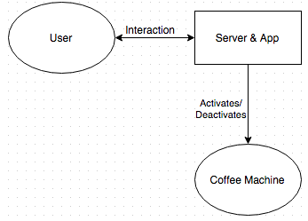

## 3.2 Additional Descriptive Items

**Product Functions**

* An app that activates a coffee machine wirelessly

**User Characteristics**

* Expecting a clean app
* The response time to be minimal

**Constraints**

* Price of an inexpensive but safe coffee machine
* Server acquisition
* Testing hardware and software phases
* Training in Java

# 4. Document Overview

The rest of the document contains a summary of reference documents, various project requirements, and the changes made to this document. The reference documents contain the other documents pertaining to the project. The requirements contain business requirements such as technology, economic, and market drivers. The requirements also include the function and non-functional requirements of the project. Lastly there is an overview of the project timeline and how the project life cycle will be implemented.

# 5. Reference Documents

Software Project Management Plan (SPMP) -- Finalized 11/4/15

# 6. Business Requirements

## 6.1 Technology

Technology drivers for this system include:

· Automated and accessible coffee maker

· Seamless app communication between user and coffee machine

· Central server to speed up logic and communication process

· Simple, clean, and intuitive user interface

## 6.2 Business

Economic drivers for this system include:

· Saves money compared to buying from a coffee shop

· User application saves time

## 6.3 Regulatory and Legal

Not Required.

## 6.4 Market Considerations

Market drivers for this system include:

· Current market price of coffee

· Access to coffee shops versus being able to swing by your home

## 6.5 Risks and Alternatives

Possible risks and alternative solutions:

* Server failure -- alternative: use of redundancy/backup server
* Network communication failure -- system of checks/handshakes to make sure commands go through
* Cross user communication -- make sure to use unique identities for each user and coffee system by pairing a unique hash with each system

## 6.6 Human Resources and Training

The team will include:

* User Interface Developer – Java/Cocoa/Swift
* Backend Developer – C++/C
* Server/Network Stack Developer – C/PHP
* Database Admin -- SQL/PHP
* C Programmer – System Design and Microcontroller Guidance

# 7. Specific Requirements

## 7.1 Functional Descriptive Detailed Requirements

***Allow user to log into system***

1. User can create a password for logging in
2. User passes a security check
3. User can change password
4. Password is saved in database with the User’s information
5. Associate user account with respective coffee machine for communication

***Allow user to activate coffee machine***

1. User activates coffee machine through User Interface.
2. Server to handle communication between app and coffee machine
3. *Activation signal is sent to the database and then to the coffee machine interface*
4. Automatically turn off coffee machine when coffee is done

***Allow user to schedule coffee***

1. User can set/modify a schedule for coffee maker to make coffee
2. User receives notification to proceed with scheduled coffee makings
3. The set time (schedule) is stored in the database
4. *The server checks database to see if the time has happened, if so, activates the coffee machine through the interface*

***Track user’s coffee intake***

1. Keep track and store coffee usage of user for 3 months
2. Allow user to view graph of coffee intake over past day/week/month

## 7.2 Requirement Uses Case

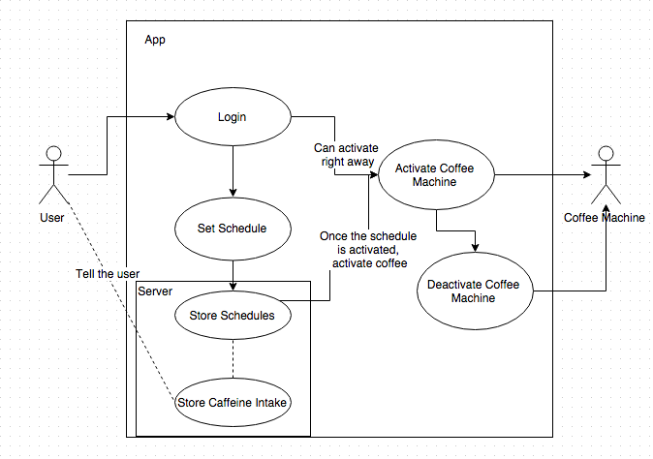

|  |  |  |
| --- | --- | --- |
| **Use Case Name** |  | **Logging in** |
| Description |  | * The user sets a password(initial). * The user can change the password later on. * The user uses the password to pass a security check to log in to the system. |
| Flow | Basic: | 1. Open application 2. Enter in username and password |
|  | Initial: | 1. Open application 2. Create account with username and password 3. Link coffee machine to account |
| Pre-Conditions |  | N/A |

|  |  |  |
| --- | --- | --- |
| **Use Case Name** |  | **Activating Coffee Machine Interface** |
| Description |  | * After the user passes the security test, they are allowed to activate the coffee machine through the system. * A message is sent to the database, to activate the coffee machine, through the coffeee machine interface. * After a set amount of time, the system sends a message to the coffee machine interface to shut off. |
| Flow | Basic: | 1. Login 2. Press button to make coffee |
|  | Alternative: | 1. User has a set schedule 2. Coffee machine activated based off of schedule |
| Pre-Conditions |  | Pass the security screening. |

|  |  |  |
| --- | --- | --- |
| **Use Case Name** |  | **Scheduling Coffee Machine Interface** |
| Description |  | * The user can designate a time to activate the coffee machine. * The time is sent to and stored on the database. * The database checks if the time has come to activate the coffee machine. * The data base activates the coffee machine, through the coffeee machine interface. * After a set amount of time, the system sends a message to the coffee machine interface to shut off. |
| Flow | Basic: |  |
| Pre-Conditions |  | Pass the security screening. |

## 7.3 Non-Functional Descriptive Detailed Requirements

* Not applicable

# 8. System Test Plan Requirements

The listing below identifies the items that have been selected as targets for testing. The list represents what will be tested.

The SQA team will be in charge of the:

Data and Database Integrity Testing:

* Verify access to database
* Verify simultaneous record and read accesses.
* Verify lockout during updates.
* Certify correct retrieval of updated data.

User Interface Testing:

* Verify navigation
* Verify screens on different devices

Performance Testing:

* Verify response time to access Smart Coffeemaker
* Verify response time to database

# 9. Qualification Provisions

*The sections were divided evenly between the team members and deadlines for progress were held (2-day section cycles).*

Before commencing the required work, the team collectively analyzed the document requirements to ensure clarity on the necessities and expectations.

To maintain quality, the team had peer reviews after sections were completed, and individual members revised the sections based on the results of the review.

Afterwards, the team members held an inspection meeting to ensure that the revisions have resolved all issues and that no new issues had appeared.

The document will be reviewed by all members of the team, as well as be presented to at least two outside persons not in the development team to check for defects as well as comprehensibility in order to verify correctness. The document will keep a record of the changes made within itself to maintain traceability. Modification will be done through the editable form of the document, and versions will be presented in a finalized version upon completion. Before the presentation of the document, all members must be reviewed once more by all members of the team, and one person on the team will conceive and direct the final formatting and presentation style to ensure completeness and consistency.

# 10. Requirements Traceability

Phone application/user interface is necessary for the user to communicate with the coffee maker. In order for the communication to take place, a central server is required to handle and process all logic and integration between application and the machine. A database is required to contain user info to discern respective machines with users and communicate data back to user application. Finally, an interface is necessary within the coffee machine to make accept commands from the central server (which come from the phone application) and then send notifications of progress back to the server and then back to the user.

# 11. Evolution of the SRS

Not applicable at this time

# 12. Rationale

Not applicable at this time

# 13. Notes

There could be additional features desired and implemented at a later time. (As of version 1.0)

# 14. Appendices

## 14.1 Schedule Tracking

|  |  |  |  |  |
| --- | --- | --- | --- | --- |
| **Artifact/Deliverable** | **Team Member** | **Estimated** | **Actual** | **Difference** |
| **Initial SRS (1.0)** |  |  |  |  |
|  | Sam | 4 | 3 | -1 |
|  | Ryan | 4 | 3.5 | -0.5 |
|  | Chia-Ching | 4 | 3 | -1 |
|  | John | 4 | 3.5 | -0.5 |
|  | Full Team | 16 | 13 | -3 |
| **Revision (1.1)** |  |  |  |  |
|  | Sam | 6 | 6 | 0 |
|  | Ryan | 6 | 6 | 0 |
|  | Chia-Ching | 6 | 6 | 0 |
|  | John | 6 | 6 | 0 |
|  | Full Team | 24 | 24 | 0 |
| **Cumulative** |  | **40** | **37** | **-3** |

## 14.2 Defect tracking

*Version 1:*

|  |  |
| --- | --- |
| Defects: | 8 |
| Revisions: | 10/18/2015 |

*Version 1.1:*

|  |  |
| --- | --- |
| Defects: | 6 |
| Revisions: | 11/3/2015 |